11.19: To find the tension 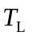in the left rope, take torques about the point where the rope at the right is connected to the bar. Then, The vertical component of the force that the rope at the end exerts must be and the horizontal component of the force is 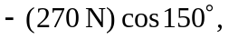so the tension is the rope at the right is 